Title Of Standard Operation Procedure (SOP)

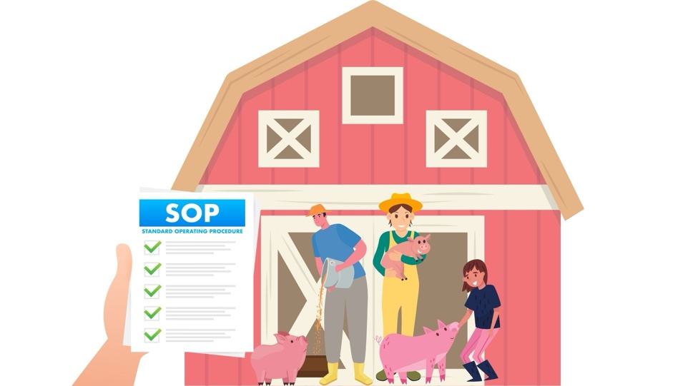

Protocol:  Example: SOP 10:5 - Weighing of finishing pigs and sows | Version:  2
Date of implementation:
30-08-2023
Author(s):

Version history (Fill in to keep track of SOP revision)

Version | Release date | Action
2 | 30-08-2023 | Example: Combined the procedure for finishing pigs and sows
1 | 15-02-2023 | -

Table of Contents
1. Purpose of the document 3
2. Equipment and material 3
3. Safety precautions 3
4. Preparation 3
5. Instructions 4
6. Documentation 4
7. References 4

Purpose of the document

Shortly describe what management procedure the SOP covers and the purpose of the SOP.

Example: This SOP describes the actions and precautions when weighing finishing pigs and sows. The weighing of growers and suckling piglets is described in other SOPs (see 7, References). The protocol is intended to minimize the animal's discomfort during the process.

Equipment and material

List the equipment and/or material needed.

Example:
- Scale (walk-in)
- Charger (is in scale)
- Driving board
- Partition board to block the width of the walkway in front of the pens
- Partition boards to block the width of the aisle where the weighing takes place
- Dust face mask
- Hearing protection
- Marking spray
- Edible treats
- Calibration weight
- Weighing list for documentation

Safety precautions

List safety precautions that should be carried out for working safety reasons.

Example:
- Wear a dust face mask and hearing protection
- Never work alone due to possible aggression from penmates when a pig is taken out of the pen
- Approach the animals calmly
- Move the partitions used to close off the weighing area with 2 people
- Wear sturdy shoes with non-slip soles when driving the pigs

Preparation

List actions of preparation needed before the actual procedure can be performed.

Example:
- Choose the right scale based on the animal weight (see labels)
- Charge this scale one day before weighing (charger is in scale)

Instructions

Write down clear instructions for how to perform the managment routin/procedure. Use bulletpoints. Photos and drawing can be added to make instructions more clear. Include instructions for callibration of equipment if applicable and for what to do afterwards.

Example:
- Calibrate the scale with a calibration weight that corresponds most closely with the estimated average weight of the pigs and, if necessary, with your own body weight.
- Move the scale to the corridor outside the pig stable and place one long side against the wall.
- Tare the scale with the doors closed and then open the doors.
- Calibrate the scale again (may deviate by a maximum of 1% from the weight measured before transport).
- Create a small space around the scale by separating off the corridor with two partitions (Fig. 1 – Drawing of the setup).
- Calmly guide a group of pigs together out of the pen and into the weighing area. Don’t chase or shout!. Use hands whenever possible, otherwise a driving board.
- Etc.

Documentation

If applicable, state what protocols/documents should be used for documentation or registration of data.

Example: Weighing list for recording of individual weights.

References

List all references referred to in the text if any.

Example:
- SOP 10:1 – Weighing of suckling piglets.
- SOP 10:2 – Weighing of growers.

