# Protocol – gilt and sow body condition score

Calibration of equipment, training and harmonization of measuring methods among staff at the facility are essential routine activities related to observation of gilt and sow body condition in pig research. Information essential to record is described below.

## General information

|  |  |
| --- | --- |
| **Scale**, brand and model |  |
| Accuracy |  |
| Date of last calibration (DDMMYY) |  |
| Signature of calibrator |  |
| **Back fat measure equipment**, brand and model |  |
| Accuracy |  |
| Date of last calibration (DDMMYY) |  |
| Signature of calibrator |  |

Back fat thickness – P2-method, 6 cm >100 kg, measure at both left and right side, use paraffin oil or equivalent product:

**Verticle line at the last rib**

**Last rib**

P2

5/6 cm

5/6 cm

## Examples of body condition score scales

Body condition scored according to the 5-grade scale, see example in this link [Body condition scoring sows | AHDB](https://ahdb.org.uk/knowledge-library/body-condition-scoring-sows#:~:text=Avoid%20variation%20and%20extremes.%20Sows%20should%20enter%20farrowing,score%20condition%203%20by%20week%20five%20of%20gestation.).

|  |  |
| --- | --- |
| **Score** | **Description** |
| 1 | **Emaciated**  Shoulders, individual ribs, hips and backbone are visually apparent |
| 2 | **Thin**  Shoulders, ribs, hips and backbone are quite easily felt when pressure is applied with the palm of the hand |
| 3 | **Acceptable / optimal**  Shoulders, ribs, hips and backbone can only be felt when pressure is applied |
| 4 | **Fat**  Shoulders, ribs, hips and backbone cannot be felt even when pressure is applied |
| 5 | **Grossly fat**  Fat deposits are clearly visible |

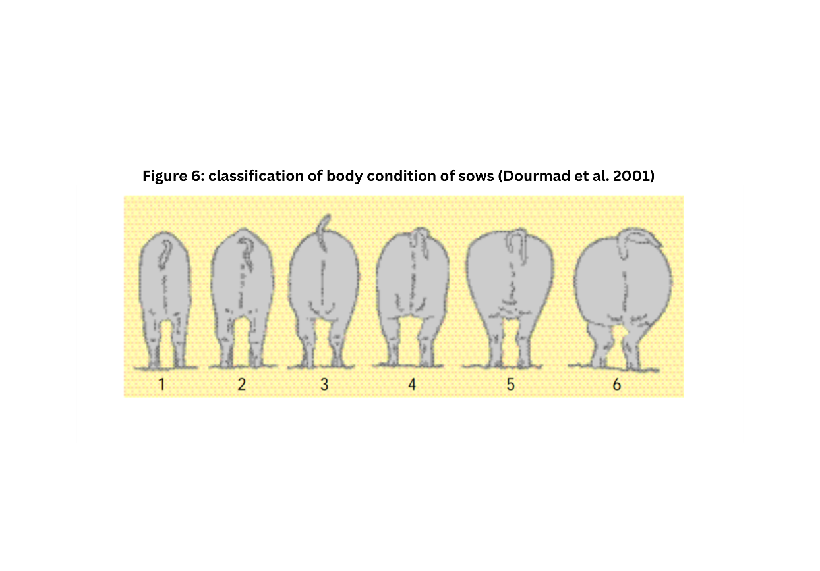

**OR:**

Scale used by Agroscope based on: Dourmad J.Y., Etienne M., Noblet J., 2001. Mesurer l’épaisseur de lard dorsal des truies pour définir leurs programmes alimentaires *[Measuring backfat depth in sows to optimize feeding strategy].* INRA Productions Animales. 14, 41 – 50.

|  |  |  |  |  |
| --- | --- | --- | --- | --- |
| Body condition score | PELVIS | FLANKS | BACK | RIBS |
| 1 | Protruding pelvic bone  Sunken in tissues around the tail base | Flanks sunken in | Protruding dorsal vertebrae along the whole length of the back | All ribs are visible |
| 2 | Pelvic bone slightly covered  Sunken in tissues around the tail base | Flanks sunken in | Certain protruding dorsal vertebrae | Slightly covered ribs |
| 3 | Pelvic bone not visible | Lumbar vertebrae not visible | Dorsal vertebrae only visible at the withers | Ribs invisible but perceptible |
| 4 | Pelvic bone only perceptible with strong finger pressure | Full flanks | Dorsal vertebrae only perceptible with strong finger pressure | Invisible and barely perceptible ribs |
| 5 | Pelvic bone imperceptible  Tail base covered in fatty tissue | Imperceptible lumbar vertebrae Full flanks | Imperceptible dorsal vertebrae | Imperceptible ribs |
| 6 | Imperceptible pelvic bone  Fatty folds around tail base and vulva | Kidneys covered in fat | Imperceptible dorsal vertebrae | Imperceptible ribs |

## Documentation of weight, back fat thickness and body condition score - example

|  |  |  |  |  |  |  |
| --- | --- | --- | --- | --- | --- | --- |
| Sow ID | Date (DDMMYY) | Occasion –  F (farrowing), W (weaning), MG (mid gestation) | Weight (kg) | Back fat thickness  left side (mm) | Back fat thickness  right side (mm) | Body condition score |
|  |  |  |  |  |  |  |
|  |  |  |  |  |  |  |
|  |  |  |  |  |  |  |
|  |  |  |  |  |  |  |
|  |  |  |  |  |  |  |
|  |  |  |  |  |  |  |
|  |  |  |  |  |  |  |
|  |  |  |  |  |  |  |
|  |  |  |  |  |  |  |
|  |  |  |  |  |  |  |
|  |  |  |  |  |  |  |
|  |  |  |  |  |  |  |
|  |  |  |  |  |  |  |
|  |  |  |  |  |  |  |
|  |  |  |  |  |  |  |
|  |  |  |  |  |  |  |
|  |  |  |  |  |  |  |
|  |  |  |  |  |  |  |
|  |  |  |  |  |  |  |
|  |  |  |  |  |  |  |
|  |  |  |  |  |  |  |
|  |  |  |  |  |  |  |
|  |  |  |  |  |  |  |
|  |  |  |  |  |  |  |
|  |  |  |  |  |  |  |
|  |  |  |  |  |  |  |
|  |  |  |  |  |  |  |
|  |  |  |  |  |  |  |
|  |  |  |  |  |  |  |
|  |  |  |  |  |  |  |
|  |  |  |  |  |  |  |
|  |  |  |  |  |  |  |
|  |  |  |  |  |  |  |
|  |  |  |  |  |  |  |
|  |  |  |  |  |  |  |
|  |  |  |  |  |  |  |

Weight, back fat thickness and body condition should be recorded for all sows at two or three occasions – the first day after farrowing, at weaning and mid gestation.